This Assessment Cover Sheet is required to be attached to your   
assessment task prior to submission for marking

|  |  |  |  |  |
| --- | --- | --- | --- | --- |
| Student Details | | | | |
| Family Name: | Ferro | | | |
| Given Name: | Alessandro | | | |
| Subject Details | | | | |
| Qualification: | Diploma of web development | | | |
| Unit Code and Title: | ICTWEB508 – Develop website information architecture | | | |
| Trainers’ Name: | Ida Ho | | | |
| Assignment Details | | | | |
| Due Date: | 24/02/2021 | Assessment No:  (If applicable) | |  |
| Date Submitted: | 24/02/2021 | | | |
| Checklist | | | | |
| * I have kept a copy of my assignment before submitting * I have completed and signed this page * I have answered all questions in the assignment * I have attached any relevant evidence/documentation, as required for the assessment | | | | |
| Declaration | | | | |
| I have been advised of the assessment requirements and have been made aware of my rights and responsibilities as an assessment candidate.  I declare that, to the best of my knowledge and belief, this assignment is my own work, all sources have been properly acknowledged, and the assignment contains no plagiarism. This assignment or any part thereof has not previously been submitted for assessment **at this or any other RTO**. | | | | |
| Student’s signature:  Alessandro Ferro | | | Date:  24/02/2021 | |

|  |  |  |  |  |
| --- | --- | --- | --- | --- |
|  | | | | |
| **Assessment Feedback** | | | | |
|  | | | | |
|  | | | | |
|  | | | | |
|  | | | | |
|  | | | | |
|  | | | | |
|  | | | | |
|  | | | | |
| **Result** | **Satisfactory** | **Not Satisfactory** | **RPL** | **RCC** |
| **NYC – New assessment date scheduled or FIR – Further information Required** | | | **Date:** | |
| Trainers/Assessors signature: | | | Date: | |
| **Student Comments** | | | | |
|  | | | | |
|  | | | | |
|  | | | | |
| * I have received my assessment result and am satisfied with the feedback given on this assessment | | | | |
| Student’s signature: | | | Date: | |

Questions:

1.1

Analyse business requirements and client expectations and discover strategic intent/ objective of the website.

**Answer**

Bazaar Ceramics goal is develop a modern ecommerce website to showcase their products, offer online payment options for their remote customers and implement better means of communication with their customers.

The above statement is a reflection of the problems the company has been facing in recent years.

An increase in the number of sales, especially remote ones, made evident to Bazaar Ceramics that the body of infrastructures and processes currently in place to sustain the company’s activity on the local market are not only expensive, but also don’t seem to provide promising margins for growth.

As a natural result, the company’s focus shifted towards broader markets and their exploration of feasible alternatives lead them to consider the implementation of an ecommerce website.

1.2

Determine business objective, goals and intent. Describe who the Target Audience is: Age

range, Gender, Education, race, Location, Religion, Politics, etc.

**Answer**

By developing an ecommerce website Bazaar Ceramics hope to:

* Improve their reach on the wider national and international market.
* Cut marketing costs related to creation and distribution of printed brochures and catalogues.
* Provide a single platform for customers to browse their products.
* Cut costs related to keeping and maintaining a gallery.
* Streamline administrative and billing tasks.
* Substiitute currently used cumbersome payment methods for remote sales.
* Refresh the company image.
* Improve customers relationship.

Considering the sector the company specialises in, the target audiene can be defined by the following characteristics:

* Adults
* Either sexes
* Value craftmanship over convenience
* Wealthy

No religious, political, ethnic, or geographical parameters are considered relevant.

On top of individuals, should be considered that a portion of Bazaar Ceramics customer base is represented by corporations.

1.3

From the requirement document, identify specific information relating to business processes and categories related/linked information into groups such as sales, purchase and procedures for bills or payments etc.

**Answer**

Sales – current process

* The current structures relies heavily on in-store sales, which due to the high operational and marketing costs, provide a low ROI.
* Remote sales require customers to fill and send a form to the company. This structure is perceived negatively by customers compared to automated process.

Sales – after website implementation

* In-store sales will largely remain unchanged.
* Remote sales will happen though the website
  + The user will browser the company’s catalogue
  + The user will click on a product to see that product’s details
  + The user will add products to the shopping cart
  + The user will checkout
  + The user will pay online

Purchase – current process

* The marketing manager produce a sales report, detailing which products have been sold the most and which are sold the least. This proccess is time consuming and prone to error.

The data provided risk to be outdated.

* The manager decide which items to produce based on the sales figures. This decision depends on the previous process, slow and subject to flaws.

Purchase – after website implementation

* The production of sales reports will be automated
  + Sales data are automatically stored in a database
  + Sales figure can be produced instantly, currently and in real time, on request from the manager. Plans for future production would be based on a more reliable source.

Billing – current process

* Billing is done manually. This process is prone to human error and time consuming.

Billing – after website implementation

* Billing will be automated by the system
  + Upon checkout the system will produce a receipt for the customer
  + The billing infomration will be stored in a database, with information to uniquely identify the customer, the products and the transaction.

Payment – current process

* Customers need to fill a form and mail it, or email it to Bazaar Ceramics for processing.

Payment – after website implementation

* Customer will be able to pay directly through the website.
  + The user will click the payment button
  + The user will enter payment details in the provided online form
  + The user will confirm the payment

Marketing – current process

* The company needs to print and distribute their brochures. The brochures become outdated quickly and need to be reprinted. The process is costly and the infomration published become outdated quikly, making it inefficient.
* The company needs to buy advertisement space on sector magazines. It represents a big cost and the reach of a magazine can be limited by its geographic distribution.

Marketing - after website implementation

* Catalogue available online 24/7
  + A customer can browse the online catalogue, search for a product or view product by category.
* Advertisement will be done online, through link from other website or by online marketing
  + A customer will click on a link, or ad, or search engine result and will be redirected to the company’s website.

Account – current process

* There a re no current processes in place to manage customers relationship.

Account – after website impleetation

* A customer will be able to create an account
  + The customer will click on the create account button
  + The customer will enter the required details in a form
  + The customer will submit the form

1.4

Determine content requirements for each process. A process can be, for example, user adding a product to a shopping cart, registration process for appointment.

Sales

* Online products catalogue
* Search bar
* Menu to select products by category
* Product details with information about the selected item (description, prices, maker, etc.)
* Checkout button

Purchase

* Admin page
* Item inventory list
* Add item button
* Add item form
  + Item name field
  + Item details field
  + Item price field
  + Item quantity field
* Remove item button
* Update item button
* Update item form
  + Item name field
  + Item details field
  + Item price field
  + Item quantity field

Billing

* Receipt page
* Download button
* Send by emmail button
* Close button

Marketing

* Same as sales

Account

* Add account button
* Registration form
  + Name
  + Email
  + Password
  + Confirm password
* Login form
  + Email
  + Password

1.5

Discover security requirements for the website.

**Answer**

* XSS
* SQL injection
* JS injection
* Path Disclosure
* Denial of service
* Code execution
* Memory corruption
* Cross site request forgery
* Information disclosure
* Arbitrary file
* Local file include
* Remote file include
* Overflow

2.1

Search the web for examples of organizational and functional metaphors. Write a brief report listing your reasons for categorizing the sites as you have.

**Answer**

TafeSA - organizational metaphor

TafeSA is an education provider which covers a wide range of subjects and qualifications.

Their website content is presented according to their organizational structure, with menus and links that highlight the various departments.

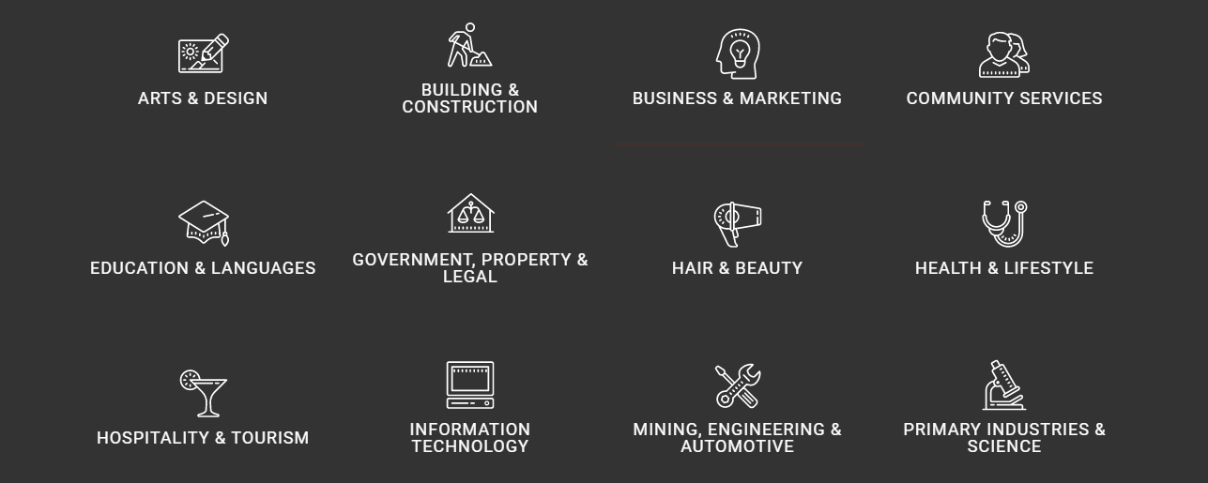

Figure 1: TafeSA departments on their home page

TafeSA offer include different types of courses aimed at different types of students.



Figure 2: Different types of courses

As a resut, website navigation is easier for visitors, that most likely already have knowledge of how an education provider is organized.

ANZ Bank – Functional metaphor

ANZ Bank website is developed around the functionalities it provides to its users. When a user access the site, is to accomplish a task, therefore the content is structured to highlight what the user can do.

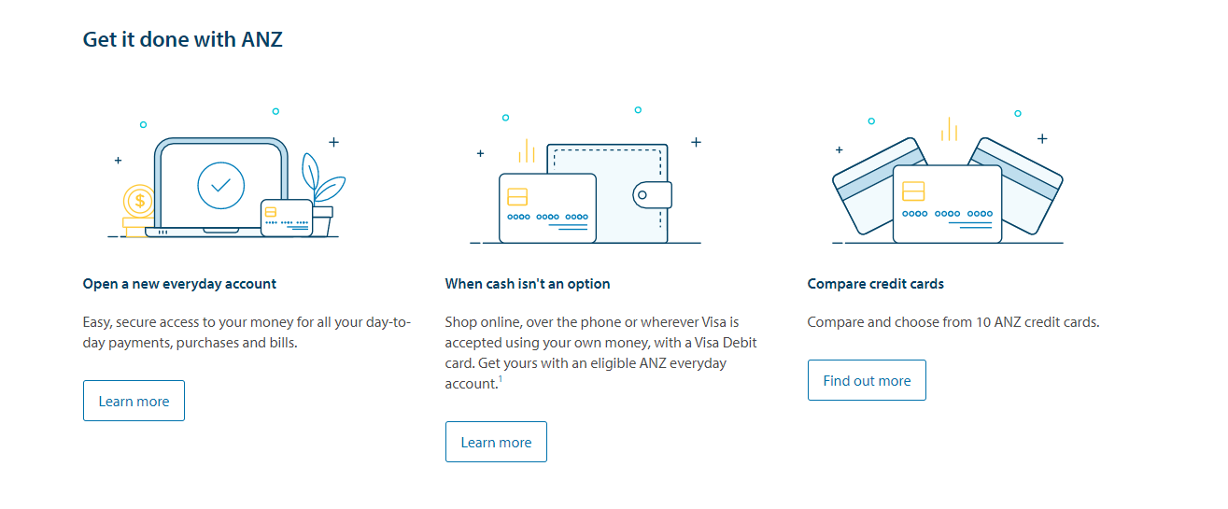

Figure 3: ANZ focus on actions more than on organizational areas

This approach allow user to quickly identify the service they need without the need to explore the organizational structure of the bank.

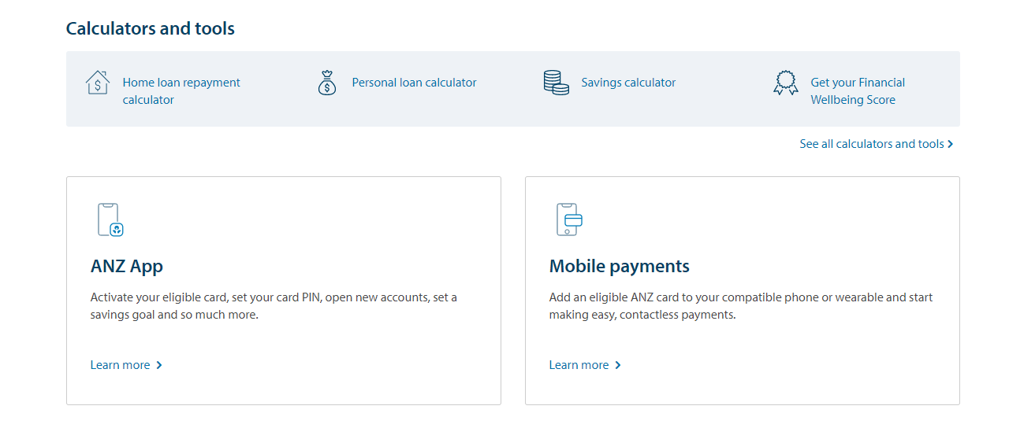

Figure 4: ANZ tasks focused approach.

In reality both approaches are likely to be used on the same website. TafeSA has a bar dedicated to specific tasks and ANZ on the other hand has an area that reflect the bank structure, as different users can visit the website for different purposes, but the guiding principle determining where the focus is put stays the same.

2.2

Design an information hierarchy which shows a logical structure to the way your website information will be organized b) Research the web for site map generators. Use it on the examples found above.

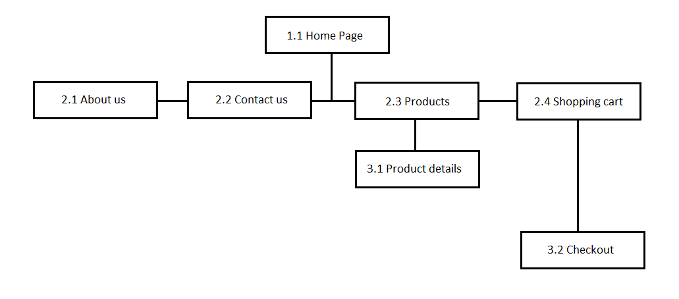

b)

TafeSA sitemap: <https://www.tafesa.edu.au/google-sitemap>

ANZ sitemap: <https://www.anz.com/auxiliary/site-map/>

2.3

A hierarchical organization also imposes a useful discipline on analytical approach to content, because hierarchies are practical only with well-organized material. Review and write a brief report on hierarchy developed by you in activity 2.2 analytical approach and restrictions on structure.

**Answer**

* The home page provides links to the “about us”, “products”, “contact us” and “shopping cart” pages.
  + The home page is not necessarily the entry point of thewebsite, but it provides an overview of what the website is and does. A user accessing the website from a different page can easily find the link to the home page and from there can navigate to whatever area of interest.

The home page can also offer information about promotions, exibitions or other content.

For these reason the home page sits at the top of the herarchy

* The “about us” page, “contact us” page, “products” page and “shopping cart” page, sit below the home page. All of them are reachable with one click from any part of the website. The “about us” page and the “contact us” page are dead ends.
  + The sole purpose of the “about us” page is to display information to the visitor
  + The “contact us” page provide functionality to send a direct message to Bazaar Ceramics.
  + The “products” page is the main focus of the website, where the company’s products can be browsed. From this page the user can access the “product details” page.
  + Although accessible by any part of the website, the “shopping cart” page is useful only when the user added products to the shopping cart. If the shopping cart is empty, a message will be displyed to the user when accessing the page.
* On the third level there are “product details” page and the “checkout” page. Both pages are on the lower level of the website.
  + The purpose of the “product details” page is to display information relative to a specific product selected by the user on the “prodcuts” page. From this page the user can only go back.
  + The “checkout” page provides the user with payment functionalities. It can be reached only by the “shopping cart” page and when the payment is finalized, it automatically redirect the user to its account page.

2.4

Create a prototype design for content labeling in Photoshop, Labels should identify content and client locations. Examples include:

1. Labels on navigation elements

2. Web page headings

3. Links

**Answer**

Navigaton menu





Navigation menu – collapsed and mobile view

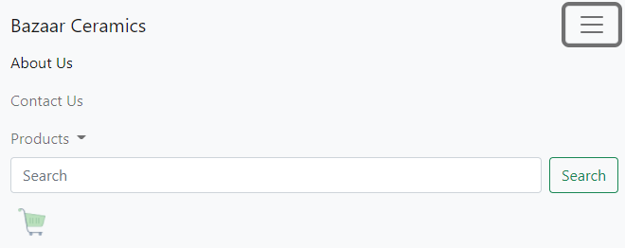

Sub-menu

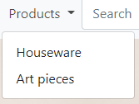 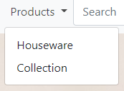

Headings

* Home page

 

* About us page

 

* Products page

 

 

* Contact us page

 

* Checkout page

 

3.1

Build a navigation map based on business requirements. Ensure ease of navigation on site and provide different ways of searching.

**Answer**

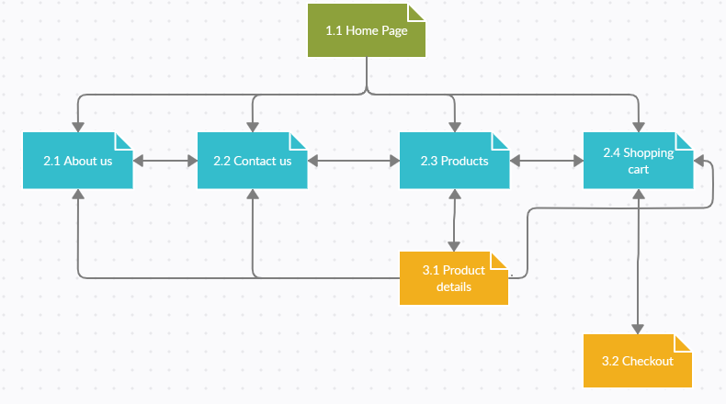

3.2

Design prototype including search¬ interface for website for navigation layout taking into account client requirements and feedback.

**Answer**

Refer to attached file: ictweb508.prototype.v1

3.3

Save activity 3.2 prototypes as Activity 3.3 and add multiple ways of navigation through site including universal navigation bar to access top levels from any page, breadcrumb navigation for accessing higher level in hierarchy. Demonstrate that navigation is accessible

**Answer**

Refer to attached file: ictweb508.prototype.v2

This second version keeps the header, navigation bar and footer in separate files that are included in each page.

Navigation has been simplified by reducing the number of pages on the second layer. Shopping cart and checkout are now on the same page. The only page on a different layer than the rest is now the “product detail” page.

4.1

Prototype was constructed in Element 3 – Develop navigation system. (Element 4.1 is covered in Element 3.2 activity)

**Answer**

Refer to previous answer

4.2

Part a) Search the web for information on "website testing", "website evaluation", "usability test", or similar terms. Develop a usability evaluation checklist. Email to your facilitator. Part b) Test the website prototype (constructed in Develop Navigation System topic) with client to test usability and if it meets the client's requirements. Provide site evaluate checklist for client to assess prototype.

**Answer**

|  |  |  |  |
| --- | --- | --- | --- |
| **Website Usability Checklist** | | | |
| **Accessibility** | **Yes** | **No** | **Comments** |
| 1. Site load-time is reasonable |  |  |  |
| 1. Adequate text-to-background contrast |  |  |  |
| 1. Font size/spacing is easy to read |  |  |  |
| 1. Flash and add-ons are used sparingly |  |  |  |
| 1. Images have appropriate ALT tags |  |  |  |
| 1. Site has custom not-found/404 page |  |  |  |
| **Identity** | | | |
| 1. Company logo is prominently place |  |  |  |
| 1. Tagline makes company’s purpose clear |  |  |  |
| 1. Home page is digestible in 5 seconds |  |  |  |
| 1. Clear path to company information |  |  |  |
| 1. Clear path to contact information |  |  |  |
| **Navigation** | | | |
| 1. Main navigation is easily identifiable |  |  |  |
| 1. Navigation labels are clear and concise |  |  |  |
| 1. Number of buttons/links reasonable |  |  |  |
| 1. Company logo is linked to home page |  |  |  |
| 1. Links are consistent and easy to identify |  |  |  |
| 1. Site search is easy to access |  |  |  |
| **Content** | | | |
| 1. Major headings are clear and descriptive |  |  |  |
| 1. Critical content is above the “fold” |  |  |  |
| 1. Styles and colors are consistent |  |  |  |
| 1. Emphasis (bold, etc) is used sparingly |  |  |  |
| 1. Ads and pop-ups are unobtrusive |  |  |  |
| 1. Main copy is concise and explanatory |  |  |  |
| 1. URLs are meaningful and user friendly |  |  |  |
| 1. HTML page titles are explanatory |  |  |  |

4.3

Test project in client's computer environment to ensure correct functions display and note any non-conformances and review design based on corrective actions. B) Browser compatibility – research browser and platform compatibility

Review the data on http://www.echoecho.com (or similar) for information regarding user platforms (hardware, operating systems, browsers) most commonly found on the Internet

**Answer**

* Home Page

|  |
| --- |
| Chrome |
|  |
| Edge |
|  |
| Firefox |
|  |

* About page

|  |
| --- |
| Chrome |
|  |
| Edge |
|  |
| Fireforx |
|  |

* Contacts page

|  |
| --- |
| Chrome |
|  |
| Edge |
|  |
| Firefox |
|  |

* Products

|  |
| --- |
| Chrome |
|  |
| Edge |
|  |
| Firefox |
|  |

* Product Detaiils page

|  |
| --- |
| Chrome |
|  |
| Edge |
|  |
| Firefox |
|  |

* Shopping Cart page – Shopping cart

|  |
| --- |
| Chrome |
|  |
| Edge |
|  |
| Firefox |
|  |

* Shopping cart page – checkout

|  |
| --- |
| Chrome |
|  |
| Edge |
|  |
| Firefox |
|  |

* Mobile view

|  |  |  |
| --- | --- | --- |
|  |  |  |
|  |  |  |

Everything displays as expected across multiple browsers and devices.

4.4

Customise your design based on feedback from mock up test. Produce a test report. The report should specify:

• what was being tested

• how it was tested

• conclusions drawn from the test

• how you intend to incorporate this feedback into the revised design.

**Answer**

The concept behind the mock up proposed to the client was to keep website usage and navigation simple and minimalistic.

Usage

* Relevant information should be immediately available to the user.
* User actions (buttons, links, menus) should be self-evident and self-explanatory
* Only necessary elements should populate the screen

Navigation

* Labels should be clear and should allow users to understand immediately where they are.
* Navigation layers should be kept to a minimum.
* First layers pages should be reachable by any part of the website.

The client sat in front of the mock up without undertaking any previous walkthrough of the website with the developer.

The test covered two specific areas:

* Difficulty in concluding a purchase.
* Overall website navigation evaluation.

In the first test, the client sat through the process of buying one item without any indication from the developers. The aim of the test was to evaluate how intuitive the usage of the system was, for a first time user. Although functionalities have not been implemented, buttons and links work and the client was able to follow the entire path from home page to checkout page easily and without needing to ask for any help.

In the second test, the client tried to reach each page of the website. Every page of the website is reachable withing a single click, aside from the product details page, which require being already on the products page. The website can be considered easy to navigate.

Cross browser compatibility testing has also been performed to ensure that every element would render properly on at least three of the major browsers. The browser used have been Chrome, Edge and Firefox. All three browsers displayed every page of the website correctly.

The website is expected to be visited by an increasing number of mobile devices users. Chrome browser offers a mobile view within the developer tools section.

The website has been tested again in mobile view and the result has been considered overall positive.

Feedback

The feedback received from the client has been positive, nonetheless the client asked to include some minor modifications, or to try different solutions than the ones included.

* Home page – the “Special offers” section could render as the “Products” section on the product page. While the current solution works in keeping the home page and the products page distinctively separated, on smaller device keeping two products per row could result in poor usability.
* Contact page – The map should be resized to make it better contained on smaller devices.

Another version with the map and the contact form swapped in each other place could be tried to see how that works.

* Product details – The client asked if there is any way to completely eliminate the second navigation layer by finding another way to display the product details.

Feedback integration

* The “Special offers” section will be re-developed, but not re-designed. It will display as it is on desktop and larger screen phones, but it will align vertically when screen size would affect it usability.
* The map will be resized and different design options will be provided to the user:
  + Map bottom – Form top
  + Map left – Form right
  + Map right – Form left
* The developer could experiment with collapsible elements or pop-ups. If the information needed are selected carefully, fewer calls to the databse may be needed while giving more information to the customer. Upon experimentation the developer may advise against this option.

4.5

Sign off prototype after receiving client approval to confirm current and future business needs are addlressed.

**Answer**

Please refer to attached file: Sign-off